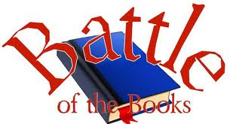
3rd – 4th 2018-19 Battle of the Books
Title | Author
The Sword in the Tree | Clyde Robert Bulla
Dandelions | Eve Bunting
The Enormous Egg | Oliver Butterworth
Henry Huggins | Beverly Clearly
Jake Drake, Bully Buster | Andrew Clements
Joyful Noise | Paul Fleischman
Honus and Me: A Baseball Card Adventure | Dan Gutman
Bunnicula: A Rabbit-Tale of Mystery | Deborah & James Howe
Invisible Inkling | Emily Jenkins
Paul Bunyan | Steven Kellogg
Orphan Train Girl | Christina Baker Kline
From the Mixed-Up Files of Mrs. Basil E. Frankweiler | E.L. Konigsburg
Rabbit Hill | Robert Lawson
Judy Moody Gets Famous! | Megan McDonald
Dinosaurs Before Dark | Mary Osborne
My Rotten Redheaded Older Brother | Patricia Polacco
How Ben Franklin Stole the Lightening | Rosalyn Schanzer
The Cricket in Times Square | George Selden
Stuart Little | E.B. White
Christopher Mouse: The Tale of a Small Traveler | William Wise

