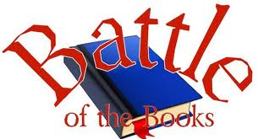
5th – 6th 2018-19 Battle of the Books
Title | Author
Crenshaw | Katherine Applegate
The Secret School | Avi
The Indian in the Cupboard | Lynne Banks
A Nest for Celeste: A Story About Art Inspiration and the Meaning of Home | Henry Cole
The Tale of Despereaux | Kate DiCamillo
Tuesdays at the Castle | Jessica Day George
Running Out of Time | Margaret Haddix
Midnight Rider | Joan Hiatt Harlow
Roller Girl | Victoria Jamieson
Slacker | Gordon Korman
Chronicles of Narnia: Lion, Witch, & the Wardrobe | C.S. Lewis
Wild Wings | Gill Lewis
Shiloh | Phyllis Reynolds Naylor
The Kite Fighters | Linda Park
Secrets At Sea | Richard Peck
Sideways Stories from Wayside School | Louis Sachar
Frozen Stiff | Sherry Shahan
The Mysterious Benedict Society | Trenton Stewart
The Trouble with Tuck | Theodore Taylor
The Crooked Kind of Perfect | Linda Urban

