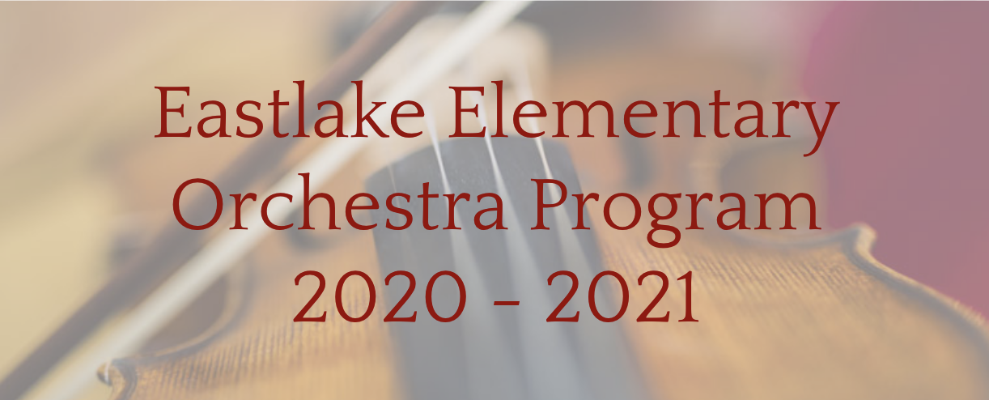

Enrich your lives forever through the study of music on string instruments. This year, the program has a new Conductor, Newell Bullen. He has a Master’s Degree in Conducting from Boston University and has conducted ensembles of many different shapes and sizes from youth choirs to broadway pit orchestras. He loves to teach and share his passion for music, especially with children and youth.

Click this link to sign up online: Online Signup Form

4th, 5th, & 6th grade students are eligible to participate

The first meeting will Wednesday September 2, 2020
- Advanced Orchestra: 7:20 AM on Mondays and Wednesdays
- Beginner Orchestra: at 8:05 AM on Mondays and Wednesdays

Tuition*: $100/Semester or $200/Year
*First Semester tuition due September 23, 2020

Musical Instrument Rental Provided by Teton Music, which is conveniently located in the Daybreak neighborhood. Students using family instruments should have them serviced by Teton Music or another instrument repair professional prior to participating in the program.

Teton Music
4198 Open Crest Dr
South Jordan, UT 84095
801.253.8920
service@TetonMusic.com
www.tetonmusic.com

Students entering the program should invite their musically inclined friends at school to join in the music and fun with them. We look forward to an exciting and unique year together!

